
MILESTONE -2

Infosys ElectViz Election Data Visualization

INDIAN GERNAL ELECTION – 2024 DATASET FROM KAGGLE

Presented by: Nalla Deepika

ABSTRACT
Elections play a vital role in a democratic country like India, allowing citizens to elect their representatives. However, election data is often large, complex, and difficult to interpret in raw form. This project focuses on analyzing Indian Parliamentary and Assembly election data using Power BI. The main objective is to transform complex election datasets into meaningful visual insights.
Through interactive dashboards and charts, this project provides a clear understanding of party performance, vote distribution, constituency-wise results, and gender participation. Power BI enables effective visualization, making election analysis accessible to political analysts, researchers, and the general public. The project demonstrates how data visualization simplifies large-scale election data and supports better decision-making.

INTRODUCTION
India follows a democratic parliamentary system where elections are conducted at both national and state levels. Parliamentary elections determine Members of Parliament, while Assembly elections elect Members of the State Legislative Assembly. These elections reflect voter preferences, political trends, and party dominance.
Analysing election data helps in understanding voting behaviour, party performance, and regional trends. With the growth of data analytics tools, election analysis has become more effective. This project uses Power BI to analyse Indian election data and present insights through interactive dashboards, making complex information easy to understand.

OBJECTIVES OF THE PROJECT
The main objectives of this project are to effectively analyze and interpret Indian election data by using modern data visualization techniques. Elections in India generate a vast amount of data, which can be difficult to understand in its raw form. Therefore, one of the primary objectives of this project is to analyse Indian Parliamentary and Assembly election data in a structured and meaningful way. By examining data from multiple election years, the project aims to uncover significant patterns and insights related to the democratic process.

Another important objective is to identify trends in party performance over different years. This helps in understanding how political parties evolve over time, how voter preferences change, and how alliances gain or lose public support. The project also focuses on studying constituency-wise and state-wise voting patterns, which allows for a detailed regional analysis of election outcomes. Such analysis helps identify strongholds of political parties and variations in voter behavior across different regions.

The project further aims to analyse gender participation in elections by comparing the performance and representation of male and female candidates. This objective supports the study of inclusivity and gender equality in Indian politics. In addition, a key objective is to create interactive dashboards using Power BI that allow users to explore election data dynamically through filters and visuals. Finally, the project seeks to simplify complex election data by converting it into clear and visually appealing reports, making the insights easily understandable for analysts, researchers, and the general public.

SCOPE OF THE PROJECT
The scope of this project includes a detailed analysis of Indian election data collected across multiple years and states, providing a comprehensive view of the country’s electoral landscape. The project covers both Parliamentary and Assembly elections, allowing comparison between national and state-level political trends. By analyzing election data over different time periods, the project helps in identifying changes in voter behavior, party dominance, and overall election outcomes.

The analysis focuses on key aspects such as vote distribution, which helps understand how votes are shared among political parties and alliances. It also examines party dominance to identify leading parties and alliances at national and state levels. In addition, the project evaluates candidate performance, highlighting top-performing candidates and constituencies. A significant part of the scope is dedicated to gender-based analysis, which studies the participation and performance of male and female candidates, supporting discussions on gender representation in Indian politics.

The project is limited to historical election data available in the dataset and does not include real-time election forecasting or prediction. External factors such as campaign strategies and voter sentiment analysis are also outside the scope. However, the project provides a strong foundation for future enhancements, including predictive analytics, real-time dashboards.

DATA COLLECTION
The dataset used in this project was collected from an open-source Kaggle repository. It contains detailed information about candidates, political parties, constituencies, votes received, registered electors, gender, and election years.
The dataset includes data from multiple election years, enabling trend analysis over time. Using open-source data ensures transparency and reliability for analysis purposes.

DATASET DESCRIPTION
The dataset consists of multiple attributes such as:
- Candidate Name
- Party Name and Party Abbreviation
- Constituency Name
- State Name
- Election Year
- Votes Received
- Total Electors
- Gender of Candidate
This structured dataset enables comprehensive analysis of election results at national and state levels.

TOOLS AND TECHNOLOGIES USED
The primary tool used in this project is Power BI for data visualization and analysis.
Other tools include:
- Power Query for data cleaning and transformation
- DAX (Data Analysis Expressions) for calculated measures
- Microsoft Excel for preliminary data review
These tools together help in creating interactive dashboards and meaningful insights.

DATA CLEANING
Data cleaning is an essential step to ensure accuracy. In this project, inconsistent values and errors were removed. Gender values such as “M” and “F” were standardized to “Male” and “Female.”
Invalid and missing data entries were handled appropriately. Column names were renamed for better clarity. Proper data cleaning improved data quality and reliability of analysis.

DATA TRANSFORMATION
Data transformation was performed using Power Query. Columns were filtered, renamed, and formatted to suit analytical needs. Date and numeric formats were corrected.
Transformation helped in restructuring raw data into an analysis-ready format, enabling smooth visualization and dashboard creation.

DATA MODELING
A star schema data model was created in Power BI. Relationships were established between fact tables and dimension tables based on keys such as constituency and year.
Proper data modelling improves performance and ensures accurate calculations. It also simplifies report creation and enhances dashboard efficiency.

DAX & FORMULAS USED
DAX formulas were used to create calculated columns and measures such as:
- Total Votes
- Average Votes per Year
- Gender-wise Vote Count
- Party-wise Performance
DAX helps in dynamic calculations and improves analytical capabilities within Power BI dashboards.
- Total Seats = SUM(PartyWiseResults[Won])
- Total Other Seats = CALCULATE([Total Seats], PartyWiseResults[Party Alliance] = "OTHER")
- Total NDA Seats = CALCULATE( [Total Seats], PartyWiseResults[Party Alliance] = "NDA")
- Total INDIA Seats = CALCULATE( [Total Seats],PartyWiseResults[Party Alliance] = "I.N.D.I.A.")
- Other Seats =CALCULATE(COUNT(ConstituencyWiseResults[Winning Candidate]),PartyWiseResults[Party Alliance] = "OTHER")
These DAX measures help analyze alliance-wise performance in the 2024 Indian General Election.

They calculate total seats, constituency-level seats, and percentage share for NDA, INDIA, and OTHER alliances.

Percentage measures support clear visualization of seat distribution.

Counting methods ensure accurate constituency-level insights.

Together, these measures form the core KPIs of the Power BI Overview Dashboard and enable meaningful comparison and clear visualization of election outcomes.

PARLIAMENTARY CONSTITUENCY ANALYSIS
This analysis focuses on Parliamentary election data to provide insights into national-level political trends. It identifies dominant political parties based on seat share and vote performance, along with top-performing cities that contribute significantly to election outcomes. The study also examines reservation category trends, highlighting the distribution of seats across different reserved and general constituencies. In addition, the analysis tracks changes in party performance over multiple election years, helping to understand shifting voter preferences. Special emphasis is placed on female participation in national-level elections, evaluating representation and performance of women candidates in Parliamentary constituencies.

ASSEMBLY CONSTITUENCY ANALYSIS
Assembly election analysis focuses on state-level electoral trends to understand regional political dynamics across India. This analysis identifies top-performing candidates by examining vote share, winning margins, and repeat victories across multiple election years. It also highlights major vote-securing states, showing how different regions contribute to overall electoral outcomes and party dominance.

A detailed constituency-wise analysis is carried out to study local voting patterns, candidate popularity, and the impact of regional issues on election results. By comparing results across constituencies, the analysis reveals variations in voter behaviour within the same state and across different states.

Special emphasis is given to candidates from Tamil Nadu, as the state demonstrates consistent and strong electoral performance over multiple election years. The analysis identifies candidates who have repeatedly secured victories, indicating stable voter support and effective political strategies. Tamil Nadu’s election data also reflects unique regional party influence and voter loyalty. Overall, this assembly election analysis provides valuable insights into state-level political trends, candidate performance, and regional voting behaviour, helping to better understand India’s diverse electoral landscape.

GENDER-WISE ANALYSIS
Gender-wise analysis examines the participation and performance of male and female candidates in Indian elections. This analysis focuses on understanding gender representation by comparing the number of male and female candidates, votes secured, and seats won across different constituencies and election years. It highlights voting trends that show how women candidates perform in comparison to their male counterparts at both national and state levels.

The analysis reveals patterns in female participation, including the growth or decline of women candidates over time. It also helps identify constituencies and states where women candidates have shown strong performance and higher voter acceptance. By visualizing gender-based data using Power BI, differences in vote share and winning percentages become easier to interpret.

Gender-wise analysis plays an important role in evaluating inclusivity in the democratic process. It encourages discussion on women’s political representation and the need for greater participation of women in Indian politics. The insights gained from this analysis can support policymakers and political parties in promoting gender equality and empowering women in leadership roles within the electoral system.

COMPARATIVE ELECTION ANALYSIS
Comparative election analysis involves studying the differences between Parliamentary and Assembly elections to understand variations in voter behavior and political trends. This analysis compares key metrics such as party dominance, total votes secured, average votes per year, and seat distribution across both election types. By analyzing these factors, the study highlights how voter preferences change between national and state-level elections.

The analysis shows that voters may support different parties at the national and state levels due to regional issues, leadership influence, or local governance performance. Party dominance is examined to identify alliances that perform consistently across both elections and those that are strong only at a particular level. Average vote comparison helps measure long-term performance trends of parties over time.

This comparative approach provides valuable insights into electoral dynamics and helps political analysts understand the impact of national policies versus state-level governance. Overall, comparative election analysis helps explain how political strategies and voter priorities differ across election types, offering a deeper understanding of India’s democratic structure.

DASHBOARD DESIGN
The dashboard design plays a crucial role in presenting election data in a clear and interactive manner. In this project, Power BI dashboards were created using various visuals such as bar charts, line charts, pie charts, slicers, and filters. These visual elements allow users to explore election data dynamically and gain insights with ease.

The dashboards are designed to provide a high-level overview as well as detailed analysis. Slicers enable users to filter data by year, state, party, alliance, and constituency, making the analysis flexible and user-driven. Line charts are used to show trends over time, while bar charts and cards display party performance, seat counts, and vote distribution.

The overall design focuses on simplicity, clarity, and visual appeal. Consistent color themes and well-labeled visuals enhance readability and user experience. By transforming complex datasets into interactive dashboards, the design ensures that election insights are easily understandable for analysts, researchers, and the general public. The dashboard effectively supports informed decision-making through data visualization.

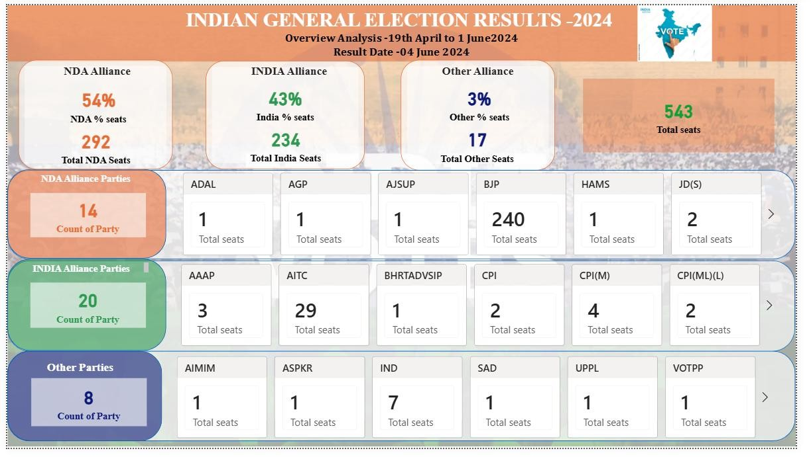

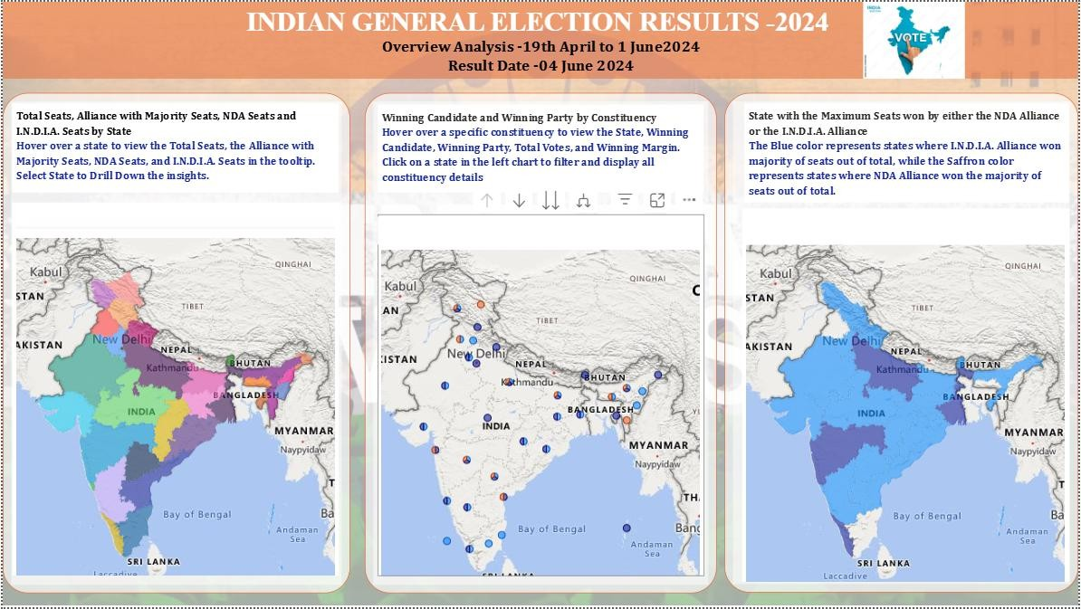

CONCLUSION
This project successfully demonstrates the effective use of Power BI in analysing and visualizing Indian election data in a clear and meaningful manner. Election data is often large, complex, and difficult to interpret in raw format. By applying data analytics and visualization techniques, this project transforms such complex datasets into interactive and easy-to-understand dashboards. The visual reports provide valuable insights into party performance, voting trends, gender participation, and constituency-wise election results at both national and state levels.

Interactive dashboards enable users to explore election data dynamically using filters and slicers based on year, state, party, and alliance. This flexibility helps in identifying political patterns, understanding voter behaviour, and analysing changes in party dominance over time. Gender-wise analysis highlights the participation and performance of female candidates, encouraging discussion on women’s representation in Indian politics. Constituency-wise analysis further supports localized insights, helping to understand regional voting trends.

By converting raw election data into visually appealing reports, the project simplifies election analysis for political analysts, researchers, policymakers, and the general public. Overall, this project proves that data visualization using Power BI plays a crucial role in enhancing transparency, improving data interpretation, and supporting informed decision-making in the democratic process.

FUTURE ENHANCEMENTS
Future enhancements of this project may include:
- Real-time election data integration
- Predictive analysis using machine learning
- AI-based voter behaviour analysis
- Web-based public dashboards
These enhancements can further improve the scope and impact of election analysis.

